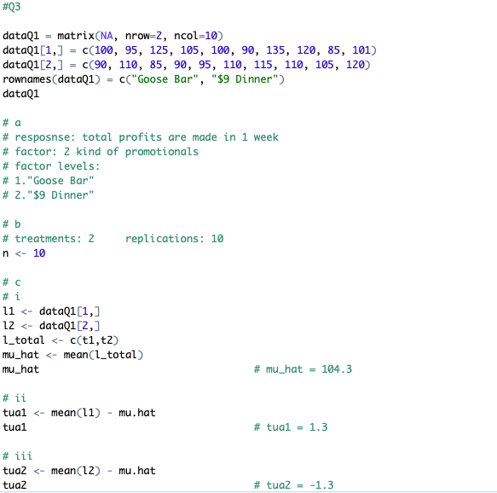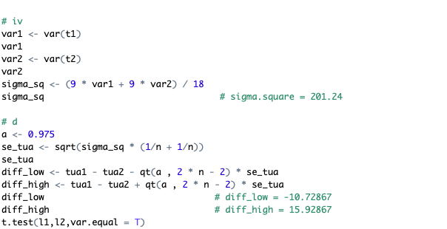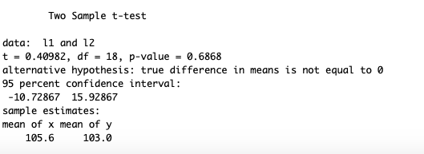

(e)

H0: tua1 – tua2 = 0

Since the confidence interval in (d) include 0 and the p value in more than the a =0.05, there is no evidence to reject the H0. in other wise, in 95% CI, tua1 = tua2

(f)

Basing on the introduction of the question, we don’t know the samples are selected randomly or nor, so I don’t think this is a reasonable assumption.